**Computational Methods in Energy Sciences**

**3rd Year Mechanical Power Engineering**

**Professor Dr Eng Ghazy Mohamed Rateb Assassa**

**Academic year 2018/2019**

**Lecture Wednesday 26-9-2017**

System: components or subsystems collaborating/interacting to achieve a defined purpose

Modeling and simulation

**System**

Physical Model

Experiment

Observed Results

Mathematical Modeling

Simulation

**Assumptions Simplifications**

Simulated Results

?

Algebraic ODE PDE

c

c

c

Euler MIT <https://www.youtube.com/watch?v=X5-ucBtneVM>

Excel Euler <https://www.youtube.com/watch?v=B6HhL90BevQ>

STEM Euler's Method of Solving ODEs

**Home work** : Euler Excel simple ODE and compare with exact solution

Come with your Laptop – 3 randomly selected students will show their work

Students will be asked to change the ODE and/or initial value in Excel

**\*\*\*\*\*\* End Wednesday 26-9-2017 \*\*\*\*\***

***********************************

**Lecture Wednesday 3-10-2017**

[http://numericalmethods.eng.usf.edu](http://numericalmethods.eng.usf.edu/)

Transforming Numerical Methods Education for STEM Undergraduates

ppt STEM Euler-mws_gen_ode_ppt_euler  OR <http://mathforcollege.com/nm/mws/gen/08ode/mws_gen_ode_ppt_euler.ppt>

Excel Euler & Exact (++) <https://www.youtube.com/watch?v=vXWb1Kspx8s>

ptt KFUPM Mid point (& Heun’s) <http://faculty.kfupm.edu.sa/coe/mudawar/cise301/lectures/CISE301-Topic8L3.ppt>

Mid point

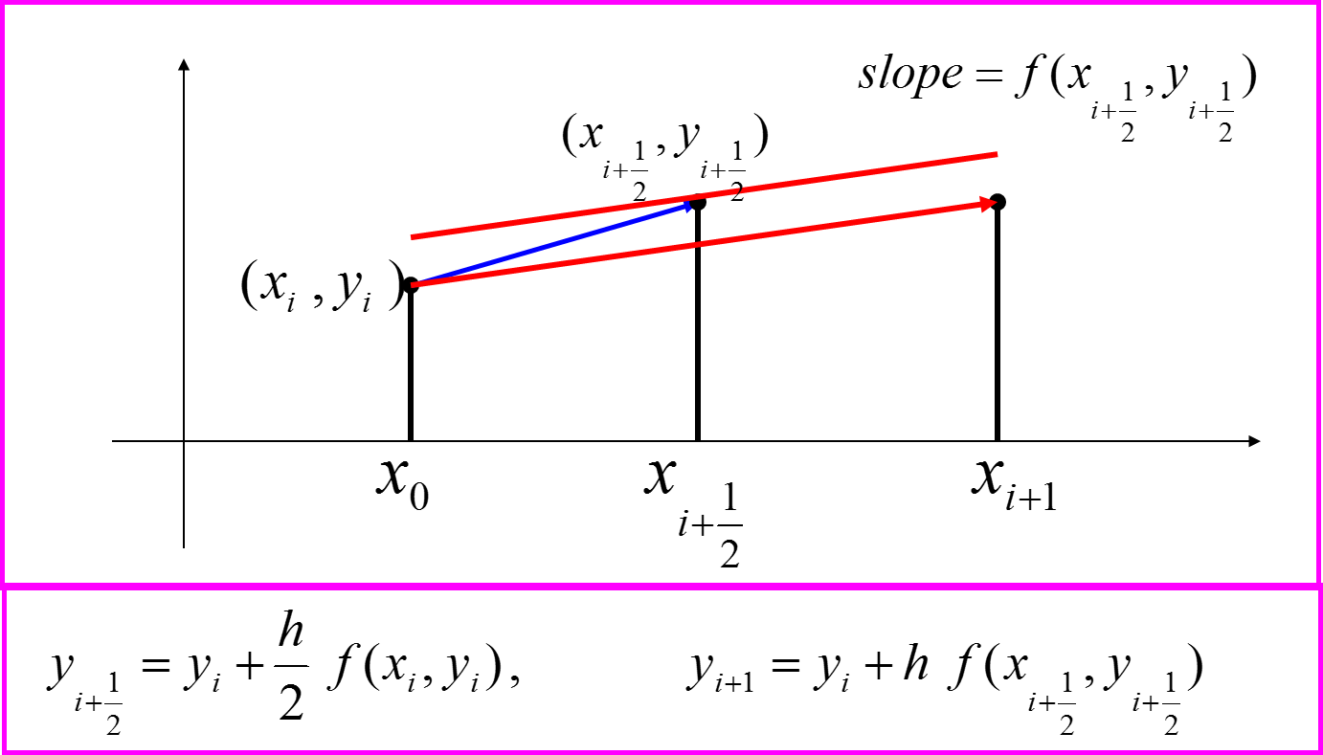

Mid Point

ptt Heun’s Method Runge-Kutta 2nd order method

**STEM Heuns** **Runge-Kutta** 2nd Order **Method OR** <http://mathforcollege.com/nm/mws/gen/08ode/mws_gen_ode_ppt_runge2nd.ppt>

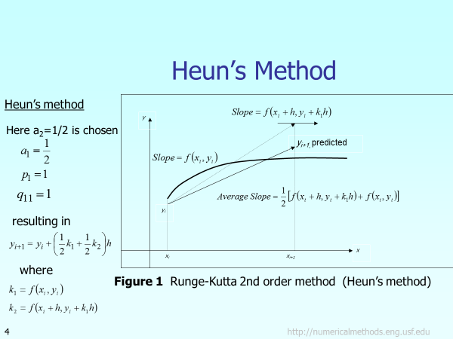

**\*\*\*\*\*\* End Lecture Wednesday 3-10-2017**

**\*\*\*\*\*\*\*\*\*\*\*\*\*\*\*\*\*\*\*\*\*\*\*\*\*\*\*\*\*\*\*\*\*\*\*\*\***

**Lecture Wednesday 10-10-2017**

Example (STEM) science, technology, engineering, and math

A ball at  is allowed to cool down in air at an ambient temperature of . Assuming heat is lost only due to radiation, the differential equation for the temperature of the ball is given by



Runge Kutta 4th Order Method: Example Part 1 of 2 <https://www.youtube.com/watch?v=AT7Olelic8U>

Runge Kutta 4th Order Method: Example: Part 2 of 2 <https://www.youtube.com/watch?v=gzgghqto1Ws>

Arabic Runge kutta method by excel <https://www.youtube.com/watch?v=BPS2wI3kCzo>

Runge-Kutta 4th System of ODEs in Excel <https://www.youtube.com/watch?v=xKaQ_ESSLSM>

Holistic Numerical Methods **Transforming Numerical Methods Education for the STEM Undergraduate** <http://nm.mathforcollege.com/#sthash.eq950tR4.dpbs>

http://demonstrations.**wolfram**.com/topic.html?topic=Fluid+Mechanics&limit=20

******* End **Wednesday 10-10-2017 \*\*\*\*\*\*\*\***

**\*\*\*\*\*\*\*\*\*\*\*\*\*\*\*\*\*\*\*\*\*\*\*\*\*\*\*\*\*\*\*\*\*\*\*\*\*\*\*\***